

**Project: Mountain Service Station**

**www.christianrochford.me/mountain**

**Author: Christian Rochford**

**Petrol Station / Newsagents**

**Project**

Create an online presence for petrol-station/newsagents.

**Timeline**

Website deliverables and their associated due dates.

**Project Analysis**

Technical Requirements – HTML5, CSS3 (Compass/Sass), Jquery.

Creative Requirements – Logo Design, Theme Development, Graphic Design and Photography.

Organisational Perspective – Priority on easily accessible information on company services.

**Site Structure**

Website to include all of the following on all pages:

Company Name – Mountain Service Station

Company Logo – see cover page (img/logo.png)

Company Tagline – N/A

Company URL – www.christianrochford.me/mountain

Main Menu – Home, Services, About Us, Community, Environment, Contact

Call-to-Action – Environmental Safety and Sustainability

**Site Pages and Structure:**

**Content Strategy**

**Page Tables**

A listing of pages and a brief description of page content.

Main Menu:

**Content**

**Home (station.gif)**

**Content Slider: Promotion of efforts to improve the environment.**

1. We’re certifiable! We’ve just been certified by BREEAM, the world leader in the evaluation and certification of sustainable buildings (sustainable.gif). (link to environment.html)
2. Keep up to date with our prices. We keep a close eye on the market and do our best to keep our costs to a minimum. Afterall, we do want you to come back to us (fuelprices.gif). (link to fuel.html)
3. Come dine with us. Our kitchens serve up delightful meals prepared with organic produce sourced from local farmers (food2.png). (link to food.html)
4. Learn some great tips on how to save money buy being more economical in your driving habits (fuelsaving.png). (link to fuelsaving.html)

**Food (food.gif)** (link to food.html)

Join us for a hearty meal or drop in for a coffee from our talented barista, you’ll want to stay longer when you get a look at our bakery. We only use organic and free range produce sourced locally.

**Car Wash (carwash.gif)** (link to carwash.html)

Want your car to shine? We put people before machines! Our car wash staff enjoy working as a team to make your car look brand new again.

**Cyclists (bicycle.gif)** (link to cyclists.html)

Our team of cyclists will take good care of you at our bicycle service station for a quick-fix to any unexpected problems. Check out our sheltered bicycle parking for when you want to take a break from the road.

**Rewards (rewards.gif)** (link to rewards.html)

We look after our regular customers. There are a few select special offers we hope you’ll enjoy. Become a member and start using the Mountain Fuel Card to save on your fuel costs.

**Services (services.png)**

**Fuel (fuel.png)** (link to fuel.html)

We’ve got 10 **unleaded petrol** and **diesel pumps**. We also have 5 separate pumps for heavy goods vehicles. We provide biofuels because we know you care about your environment (link to environment.html) as much as we do. All of our pumps are available 24/7 and allow you to pay at the pump via laser or credit card. We also care for your car’s inner beauty so we stock the finest choice in engine oils (link to oil.html).

**Car Wash & Service (carservice.gif)** (link to carwash.html)

We believe that a small business should support the community (link to community.html) that supports them. We’ve replaced that big ugly car wash machine with a team of great folk who want to get back to the workforce and do an incredible job at cleaning cars, inside and out. Our team will make your car smile.

**Cyclists (cyclists.png)** (link to cyclists.html)

We love to cycle as much as we love to drive. So much so that we’ve teamed up with our local cycling club (link to project.html) to support their race days. We want to ensure that cyclists are as welcome taking at pit-stop here as much as any driver. Our team of cyclists will take good care of you at our bicycle service station (link to cyclists.html) for a quick-fix to any unexpected problems. Check out our sheltered bicycle parking for when you want to take a break from the road.

**Food & Shop (food2.png)** (link to food.html)

Have you tried a coffee from our top class barista? How about a healthy snack from our diner? We only use organic and free range produce sourced from local farmers (link to community.html). Have a freshly baked pastry from our bakery while reading today’s paper and make yourself at home. If we get to know you we’ll reward you (link to rewards.html) with a bit more to satisfy your appetite.

**About Us (about.gif)**

Mountain Service Station all started when three brothers identified the need for a service station which looks after its environment and supports its community. We’re a family run business which depends on the community and, as such, support our community as much as we can in return.

**Strategy & Vision**

We’ve got a passion for the environment and have built our business on this with an aim to share our passion with the community. Our service station is a sustainable project which has been certified by BREEAM (external link), the world leader in the evaluation and certification of sustainable buildings. We see our business as more than a place to fuel your car and as such aim to provide you with a homely environment where you can relax without having to drive in. We’re big fans of cycling (link to cyclists.html) and strive to provide a place where cyclists are as at home with us as our drive-in customers. We also hope you’ll be happy to simply walk-in to enjoy a great service in our café and diner (link to food.html).  
  
**Local Presence**

With a strong connection to our local community (link to community.html) we have worked hard on building a local presence among our neighbours and feel our business has benefited greatly from our community projects. We work hard to promote integration amongst people with different abilities both at the workplace and outside (link to careers.html). Since the beginning we have been promoting a committed and supportive model of social coexistence, improving people's quality of life and helping to bring about the social integration of groups that are most disadvantaged or most at risk of exclusion.

We share a love of good food, to supply a wealth of local and artisan produce to the residents of the surrounding area. All of our food is prepared with organic and free-range produce from local farmers (link to community.html). Come by on a Saturday morning as the car park buzzes with the activity of stalls setting up and the first customers arriving for our weekly farmer’s market.

**Community (community.png)**

As individuals, our impact is limited, but when we pool our resources and work together so much can be accomplished. We are grateful that our community gives to us on a daily basis so we love to give back to our community. Below are some brief descriptions of how we work together.

**Employment projects (employment.gif)** (link to careers.html)

Our community employment project is designed to help people who are long-term unemployed and other disadvantaged people to get back to work by offering part-time and full-time placements. We work hard to promote integration amongst people with different abilities both at the workplace and outside. Since the beginning we have been promoting a committed and supportive model of social coexistence, improving people's quality of life and helping to bring about the social integration of groups that are most disadvantaged or most at risk of exclusion.

**Farmer's market/produce (market.gif)**

We work closely with local farmer’s to provide only free-range and organic produce in our café and diner (link to food.html). All of our freshly baked goods are also produced locally. If you’d like to meet our local suppliers in person then come by at the weekend as every Saturday we host a Farmer’s Market with stalls showcasing a wealth of local and artisan produce from local farmer’s and suppliers.

**Supporting local cyclists (bicycle.gif)** (link to cyclists.html)

Our ‘Get On Your Bike’ project has been a great success. We love to cycle and would like to help you get back on two wheels. We’ve teamed up with our local mountain-biking club to help them stay on track (link to project.html). We’re strong supporters of the cycle to work scheme and our team of cyclists will take good care of you at our bicycle service station for a quick-fix to deal with any unexpected problems. Check out our sheltered bicycle parking for when you want to take a break from the road.

**Environment (environment.gif)**

Energy can neither be created nor destroyed, it can only be transformed. Before we started we wondered what the service station of the future would be like. Today you can see it for yourself.

**Sustainable service station**

During operation of the service station we reduce on-going energy costs through selection of alternative efficient materials and designs. We have considerably improved the insulation value of the building by using a built up roofing system. Our glazing specification has been improved to decrease summertime heat gain, and wintertime heat loss. Modern refrigeration packages allow for heat recovery for heating the shop and water and we are increasing our use of LED low energy lighting. Our latest addition is the use of “grey water” harvesting from gutters and the canopy for flushing toilets and car washing.

We implement consumption control for water, electricity, air, heaters and coolers. Our toilets use a waterless urinal system which saves 10,000 litres of water every year. We provide parking, paths and equipment for cyclists. Our building is insulated with sheep’s wool, a natural and safe alternative. We provide recycling points for organic waste, paper, plastic, glass and batteries. All of our electric signage is powered through solar panels.

Our service station is the first in Ireland to be BREEAM (external link) certified, the world's leading design and assessment method for sustainable buildings.

**Fuel saving tips** (link to fuelsaving)

We’ve provided 10 very useful tips from The European Petroleum Industry and the European Commission to help you drive more efficiently. The way you drive is not only important for you, your families and others. It also matters to our environment. These efficient driving tips will help you reduce fuel consumption and contribute to cleaner and safer lifestyles. We hope you will find these tips helpful.

**Contact (Google-<iframe>map image</iframe>)**

We are located at the foot of the mountains and at the doorway to the city. It’s the perfect spot to recharge both yourself and your vehicle. Take the Sandyford exit off the M50 and turn up to Mountain Rd where you’ll find us waiting for you.

Address: Mountain Service Station, Mountain Rd, Sandyford, Dublin.

Phone: 01-MOUNTAIN

Feedback form. Include Name, Email & Message.

To contact us regarding employment please followthe application instructions on the following page. (link to careers.html)

**Fuel (fuelpump.gif)**

**Up To Date Fuel Prices**

This petrol pricing information is based on all fuel filling stations in Ireland. We do our best to keep cost at a minimum.

We guarantee that motor fuel purchased from Mountain Service Station is genuine quality fuel and fully complies with EU and Irish Fuel specifications. Alongside standard petrol, unleaded and diesel you can also choose from our new options:

Bioethanol - Drivers of standard petrol powered vehicles can use this bio-fuel without risk to the car manufacturer’s warranty.

Biodiesel - Biodiesel can now be used in standard diesel vehicles and is a blend of regular mineral diesel and up to 10% bio-diesel.

Our service station provides 10 **unleaded petrol** and **diesel pumps**. We also have 5 separate pumps for heavy goods vehicles. We provide additional biofuel pumps because we know you care about your environment as much as we do. All of our pumps are available 24/7 and allow you to pay at the pump via laser or credit card. We also care for your car’s inner beauty so we stock the finest choice in engine oils (link to oil.html). Read more to learn about fuel saving tips (link to fuelsaving.html).

**What determines our prices (fuelprices.gif)**

In the Republic of Ireland, tax (excise duty and VAT) is by far the single largest component of the pump price. Cost of product is also a major factor. Crude oil is a commodity traded on international markets and from it a whole variety of products are refined including petrol, diesel, heating oil, jet fuel. There is also a very competitive Irish motorfuels market where we strive to stay on top.

**Traceability & Quality (traceability.gif)**

Our Guarantee to you is that our fuels are Quality Assured; they will respect your engine and their supply can be traced directly to the terminal from which they originated.

**Car Wash (car.gif)**

We put people before machines! Our car wash staff enjoy working as a team to make your car look brand new again. Our team love their jobs and work hard to make your car smile. We’ve replaced that big ugly car wash machine with a team of great folk who want to get back to the workforce and do an incredible job at cleaning cars, inside and out.

Our community employment project (link to community.html) is designed to help people who are long-term unemployed and other disadvantaged people to get back to work by offering part-time and full-time placements. We work hard to promote integration amongst people with different abilities both at the workplace and outside. Since the beginning we have been promoting a committed and supportive model of social coexistence, improving people's quality of life and helping to bring about the social integration of groups that are most disadvantaged or most at risk of exclusion.

**Description of services (carservice.gif)**

Hand Wash, Vacuum clean incl Boot, Mat wash, Dash Board Polish, Tyres polished, Door Ledges Cleaned, Windows (inside & outside), Interior Vinyls, Scent, Tar removal.

**Cyclists (bicycle.gif)**

Our ‘Get On Your Bike’ project has been a great success. You don’t need to drive to enjoy our services. We love to cycle and would like to help you get back on two wheels. Have a look at how we’ve teamed up with our local mountain-biking club to keep them on track (link to project.html).

We love to cycle as much as we love to drive. We’re strong supporters of the cycle to work scheme and we want to ensure that cyclists are as welcome taking at pit-stop here as much as any driver. Our team of cyclists will take good care of you at our bicycle service station for a quick-fix to any unexpected problems. We provide sheltered parking, cycling paths and equipment for cyclists.

Here’s a list of just some of the bicycle repair services we provide in our bicycle service station:

Puncture (includes standard replacement inner tube)

Service (strip, clean, grease and adjust)

Fit new tyre

Service headset (strip, clean, grease and adjust)

Service brakes (check pad wear, clean and lubricate parts, lubricate cables, adjust)

Bleed hydraulic disc brakes and adjust (front and rear)

Fit new disc brake rotor

Service gears (check chain wear, clean and lubricate chain, moving parts, cables and adjust)

Adjust gear indexing

Replace chain

Suspension: We can arrange servicing of your suspension unit, please contact us for further information on this service.

All other work, including fitting new parts, will be charged based on the amount of time it takes rather than having a fixed price for each item.

**Food (dining.gif)**

**Changing the world one meal at a time.**

We are the first and only certified organic service station restaurant in Ireland. We source all produce from local farmers and local suppliers of quality free-range and organic food (link to community.html). Our menu includes free-range meats and a great selection of vegetarian and gluten-free options. If we get to know you we’ll reward you with a bit more to satisfy your appetite, have a look at our Rewards (link to rewards.html).

**The Mountain Diner (diner.gif)**

Come dine with us and choose from a great selection of healthy and hearty meals. Open daily from 6am to 10pm serving breakfast, lunch, dinner and everything in-between.

**The Mountain Café (café.gif)**

Have you tried a coffee from our top class barista? If you have I’m sure you’ll be looking for more. We also provide a large selection of teas for those look for something different.

**The Mountain Bakery (bakery.gif)**

Have a freshly baked pastry from our bakery while reading today’s paper and make yourself at home. Our bakery serves a selection of breads and pastries and also boasts a great variety of gluten-free options.

**Oil (engine.gif)**

Buying and running a car or motorbike is one of the most important investments we make in our busy lives. Because of the value we place on our motors, it is very important to protect the engine by choosing the correct lubricating oil. We stock a full range of engine and other oils to meet your needs and to keep your vehicle beautiful on the inside.

**Mountain Engine Oil (oil.gif)**

Mountain Engine Oil is made from reclaimed motor oil. As a result, it takes up to 85% less energy to produce than oil refined from crude. Which means it is better for your engine and for the environment.

**Reliable Engine Protection (car2.gif)**  
Mountain Engine Oil meets or exceeds the toughest European standards for engine protection. Its unique blend helps to reduce oxidation and protect against viscosity and thermal breakdown. This can add miles to your engine life.

**Sustainability (sustainable.gif)**  
Mountain Engine Oil is more than just motor oil. It's part of a much bigger effort helping us to help you contribute to a sustainable environment (link to environment.html).

**Rewards (rewards2.gif)**

**Fuel Discounts for Regular Customers**

## We can guarantee you 2 cent off per litre every time you purchase fuel (link to fuel.html) at our service station. The Mountain Fuel Card is free to members and so easy to use, just swipe your card to purchase your fuel and save every time. Call in to become a member and pick up your card to start saving.

**Convenient Payment by Direct Debit**

Keeping an eye on your savings couldn’t be easier, we will keep you updated by email every 2 weeks and your direct debit goes out 7 days later. This means that your fuel bill is easily recognised on your bank statement and there is no need for cash or credit cards at the petrol station.

**E-Billing and up to 21 days Interest Free Credit**

Mountain Fuel Card holders will receive their invoices by email on a regular basis through e-billing. Your e-statement will clearly show your savings every 14 days, while all your purchases will be paid conveniently by direct debit 7 days later giving you up to 21 days credit.

**Rewards for regular diners**

If you come by for a coffee or a meal (link to food.html)on a regular basis we’ll look after you. We’ll reward you with food and beverage rewards when you collect a token with each purchase in our café or diner.

**Projects (project.png)**

**Collaboration with Mountain Road Cycling Club.**

Mountain Service Station has actively sponsored the Mountain Road Cycling Club since 2005. We’ve provided its cyclists with the team-kit and some of our great staff are members of the club, which has 42 members and has been operating for eighteen years.

Its activities are focused on mountain-biking, with group outings on Sundays, varying the routes based on specific types of training. Members also participate in popular races throughout the country and we have recently supported some of the club’s members in travelling overseas to joining the European Mountain-Biking Championship. Our **interest in sponsoring sports, and in this case mountain-biking, came about from this collaboration.**

The number of participants in this sport increases year after year. For this reason we affirm our commitment to mountain-biking in 2012 with our contribution to funds for the building of a new centre for the Mountain Road Cycling Club. The experience gained from our collaboration with the club for so many years means we have a first-hand understanding of the world of mountain-biking and cyclists’ requirements, which has led to the creation of our bicycle service centre (link to cyclists.html), with the most **modern facilities and the best services** to meet the needs of the most demanding cyclists.

**Fuel Saving (fuelsaving.gif)**

Check the oil level regularly. A correctly maintained car operates more efficiently and can help reduce CO2 emissions.

Check your tyre pressure monthly. Under-inflated tyres can increase fuel consumption by up to 4%.

Remove unnecessary weight from your car. The heavier the car, the harder the engine has  
to work and the more fuel it will consume.

Close your windows and remove empty roof racks. Reduction of wind resistance can lower your fuel consumption and CO2 emissions by up to 10%.

Use air conditioning only when necessary. Unnecessary use increases fuel consumption and CO2 emissions by up to 5%.

Avoid leaving the engine running to save fuel and turn off the engine when stationary for more than one minute.

Drive at reasonable steady speeds. Every time you accelerate or brake, your engine uses more fuel and produces more CO2.

When accelerating, change up gears as early as possible. Higher gears are more economical in terms of fuel consumption.

Try to anticipate traffic flow. Look at the traffic as far ahead as possible in order to avoid unnecessary stopping and starting within the flow of traffic.

Consider car sharing for work or leisure. You will help reduce congestion and fuel consumption.

**Careers (careers.png)**

**Employment projects**

Our community employment project is designed to help people who are long-term unemployed and other disadvantaged people to get back to work by offering part-time and full-time placements. We work hard to promote integration amongst people with different abilities both at the workplace and outside. Since the beginning we have been promoting a committed and supportive model of social coexistence, improving people's quality of life and helping to bring about the social integration of groups that are most disadvantaged or most at risk of exclusion (link to community.html).

What we look for in our staff:

A passion for service is a must.

Experience working with the public is a bonus.

High comfort level with working in a team and interpreting direction and feedback.

Listening ears. A willingness to hear, understand, and follow a plan.

Someone who knows how to disagree without arguing.

**Positions available:**

Currently we have no positions available but if you’re interested in joining our team you can send us an email at the following address with a short summary of why you’d like to work for us.

**Contact email address: jobs@mountainss.ie**

**SEO Strategy**

Keywords: mountain, service station, Dublin, Ireland, fuel, petrol, diesel, engine oil, sustainable, environment, community, cycling, café, bakery, diner, farmer’s market, local service.

Page Titles & Descriptions:

|  |  |  |
| --- | --- | --- |
| Page | Title | Description |
| Home | Mountain Service Station Home | Homepage of Mountain Service Station, Dublin. Ireland’s first sustainable service station. |
| Services | Services Available at Mountain Service Station | We’re not only about cars. View the variety of great services available at Mountain Service Station. |
| About | About Mountain Service Station | Find out more about the strategy and vision behind Mountain Service Station |
| Community | Mountain Service Station and the Community | Learn about how we work closely with the local community to provide a better environment for everyone. |
| Environment | Mountain Service Station and the Environment | Learn about our passion for the environment and how we work hard to make our business a sustainable workplace. |
| Contact | Contact Mountain Service Station | Location and contact details for Mountain Service Station. We’ll put you on the right path. |
| Fuel | Fuel services at Mountain Service Station | Find out about the great fuel services provided by Mountain Service Station. Choose from a selection of eco-fuels for all vehicle types. |
| Car Wash & Service | Car Wash & Service at Mountain Service Station | Find out about our famous traditional car wash and service station which will have your car looking brand new in no time. |
| Cyclists | Cyclists at Mountain Service Station | We support cyclists 100%. Find out more how our team at Mountain want to see you back on two wheels. |
| Food | Dining at Mountain Service Station | Relax at our café and bakery or choose from our healthy and hearty delights at the Mountain Diner. We pride ourselves on our menu’s delicious and healthy options. |
| Projects | Mountain Service Station Community Project’s | Read about our project to support the local mountain-biking club and how we’ve done great things together. |
| Fuel Saving Tips | Mountain Service Station’s Fuel Saving Tips | Here at Mountain Service Station we care for the environment and want to help you do the same. Lear how to contribute by changing how you drive. |
| Careers | Careers at Mountain Service Station | Read about our employment projects and find out about available positions. |
| Engine Oil | Mountain Service Station Engine Oil | Mountain Engine Oil is made from reclaimed motor oil, which means it is better for your engine and for the environment. Its unique blend helps to reduce oxidation and protect against viscosity and thermal breakdown. This can add miles to your engine life. |
| Rewards | Mountain Service Station Rewards | Learn how to save money on your fuel costs by getting a free Mountain Fuel Card. |

**Sitemap –** server side(xml) and browser side (html).

**Google analytics -** tracking on all pages.

**Wireframes**

home.html services.html

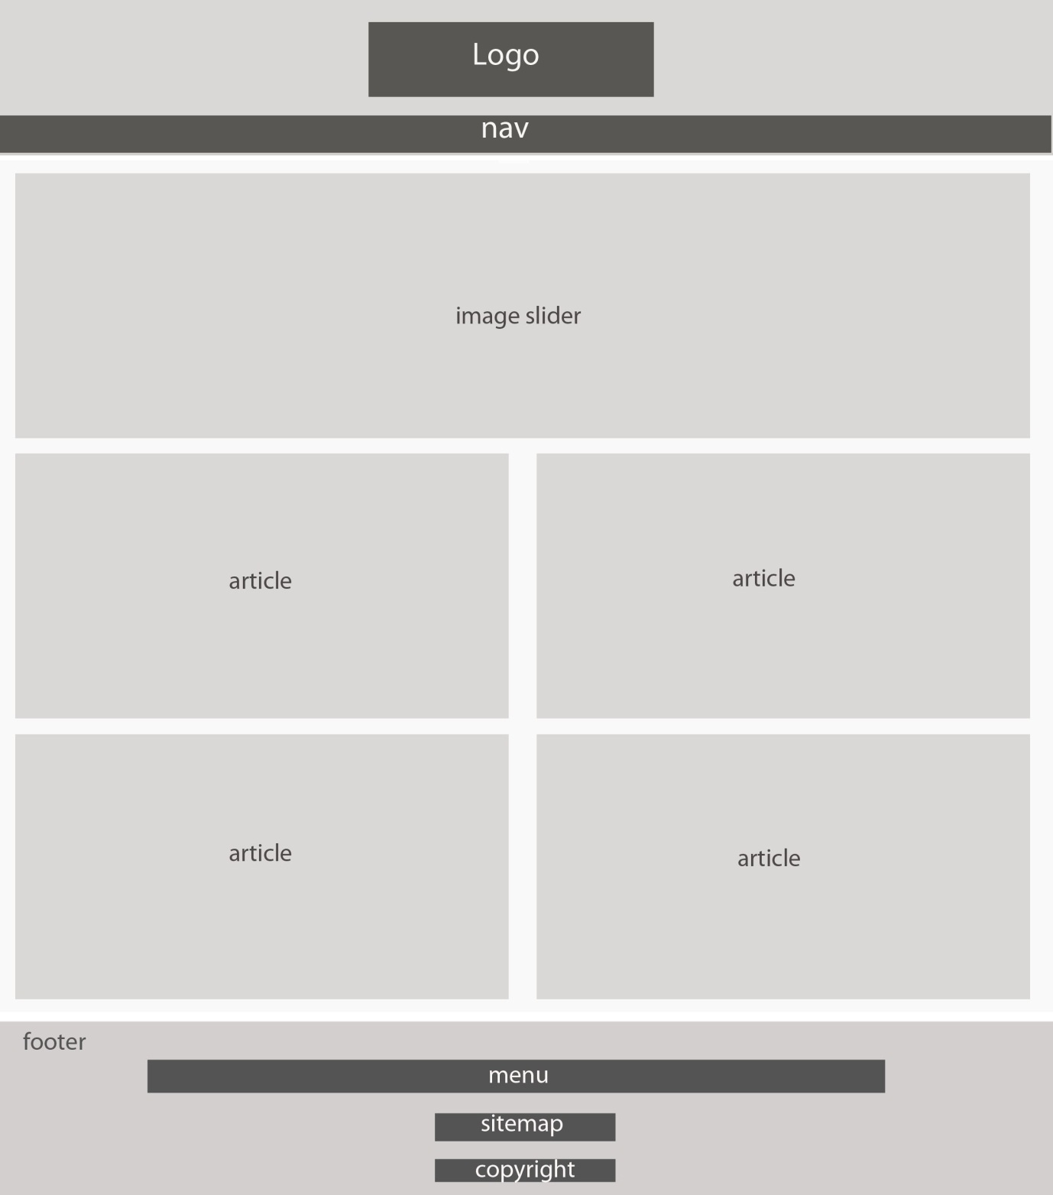

about.html, carwash.html

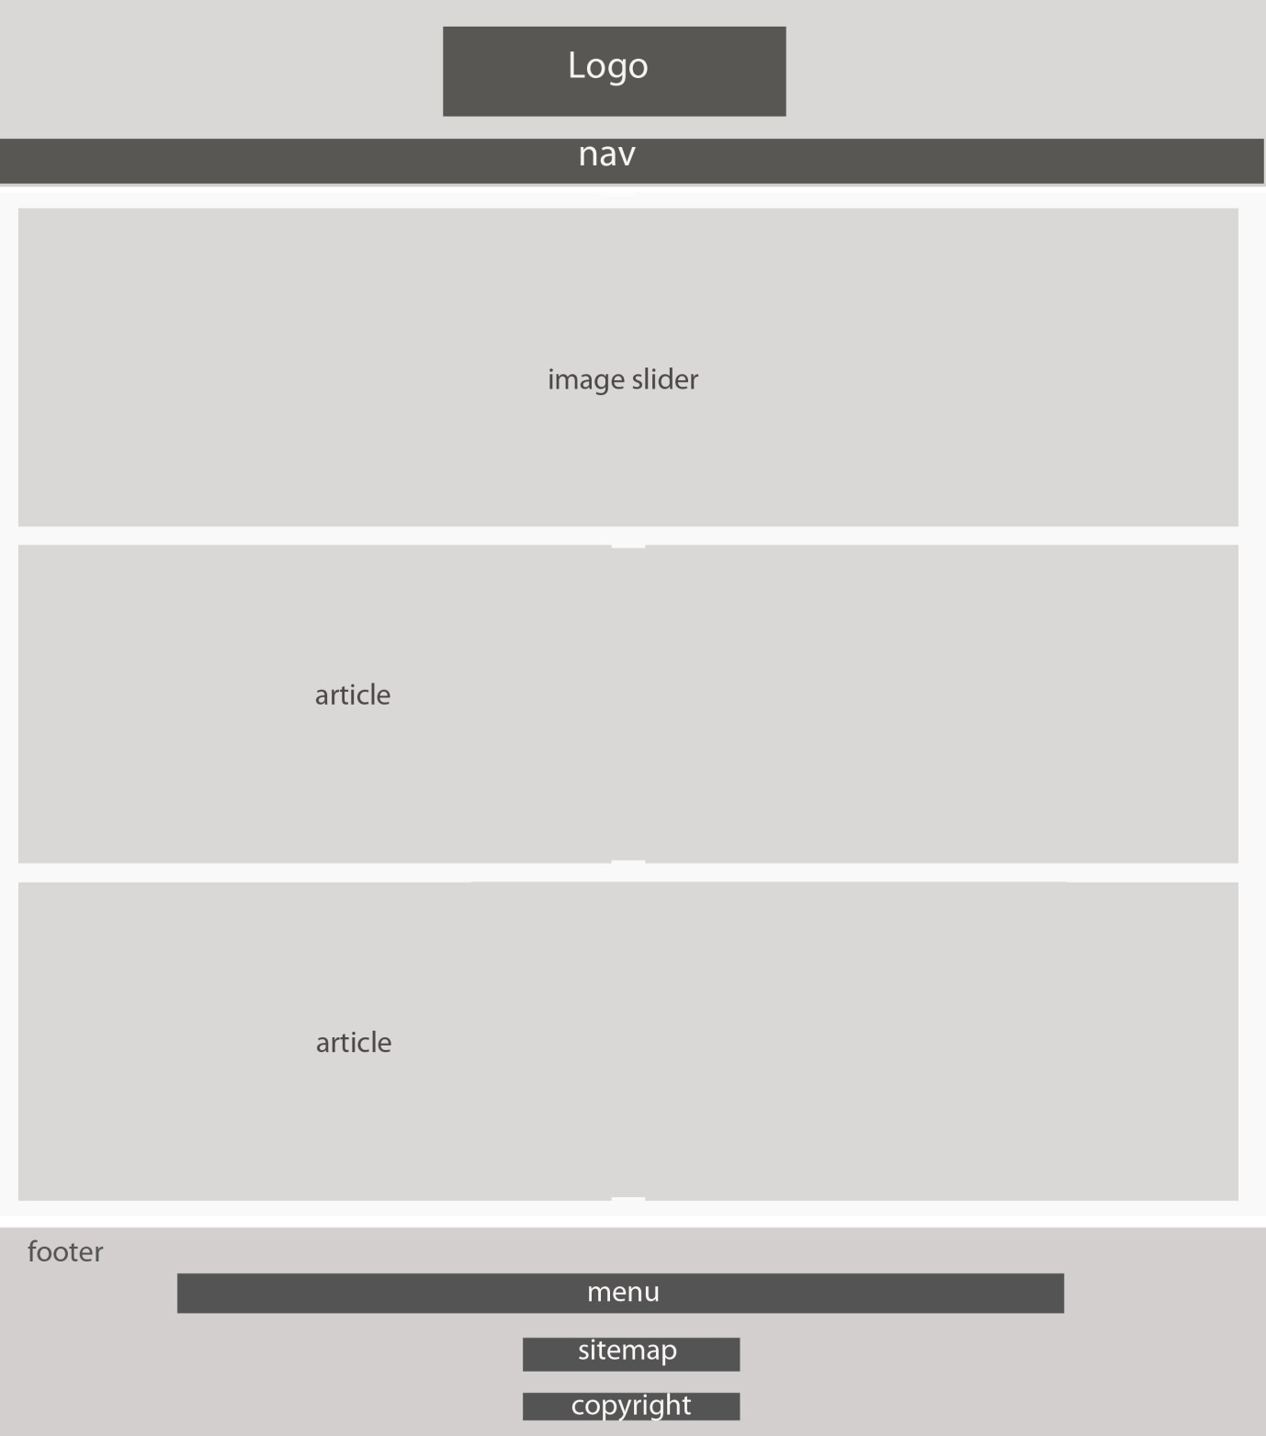

careers.html, rewards.html, contact.html, fuel.html, oil.html

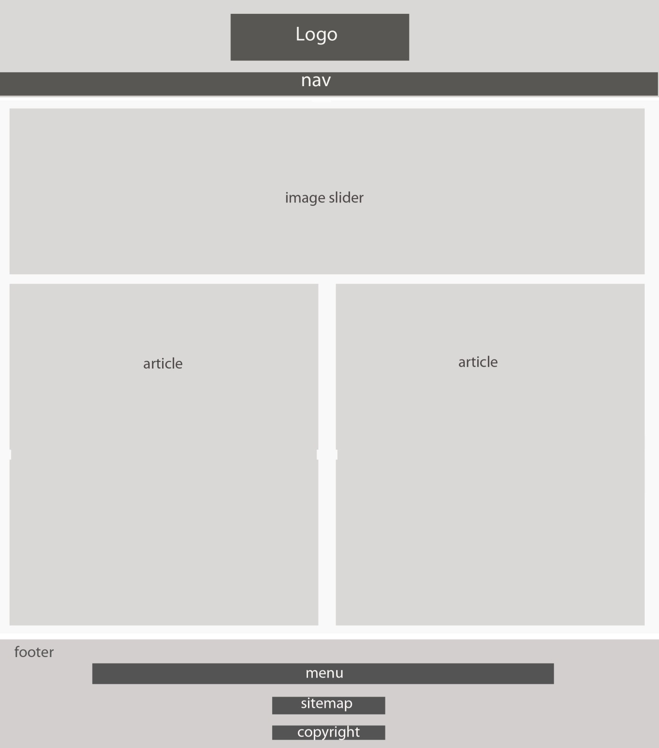

community.html, food.html

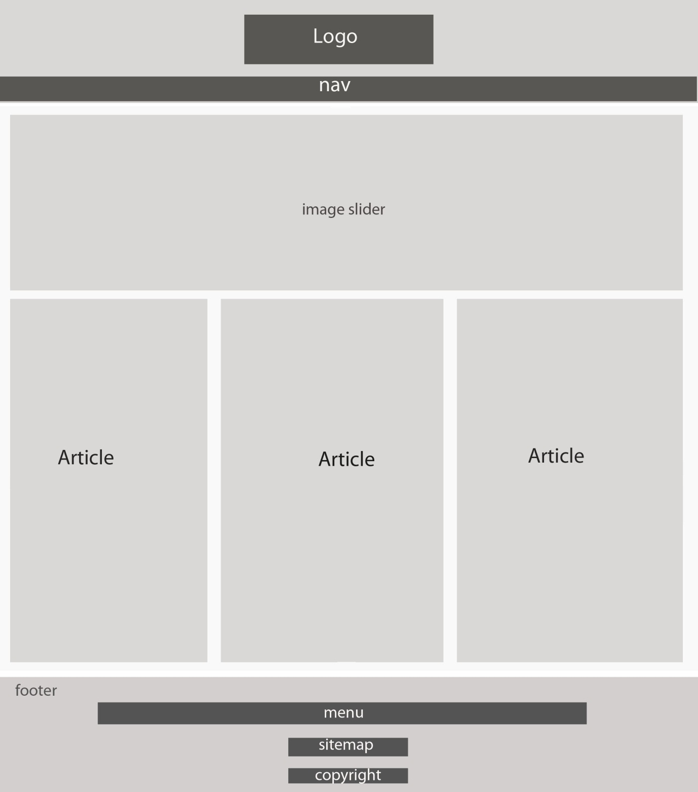

environment.html, cyclists.html, project.html, fuelsaving.html

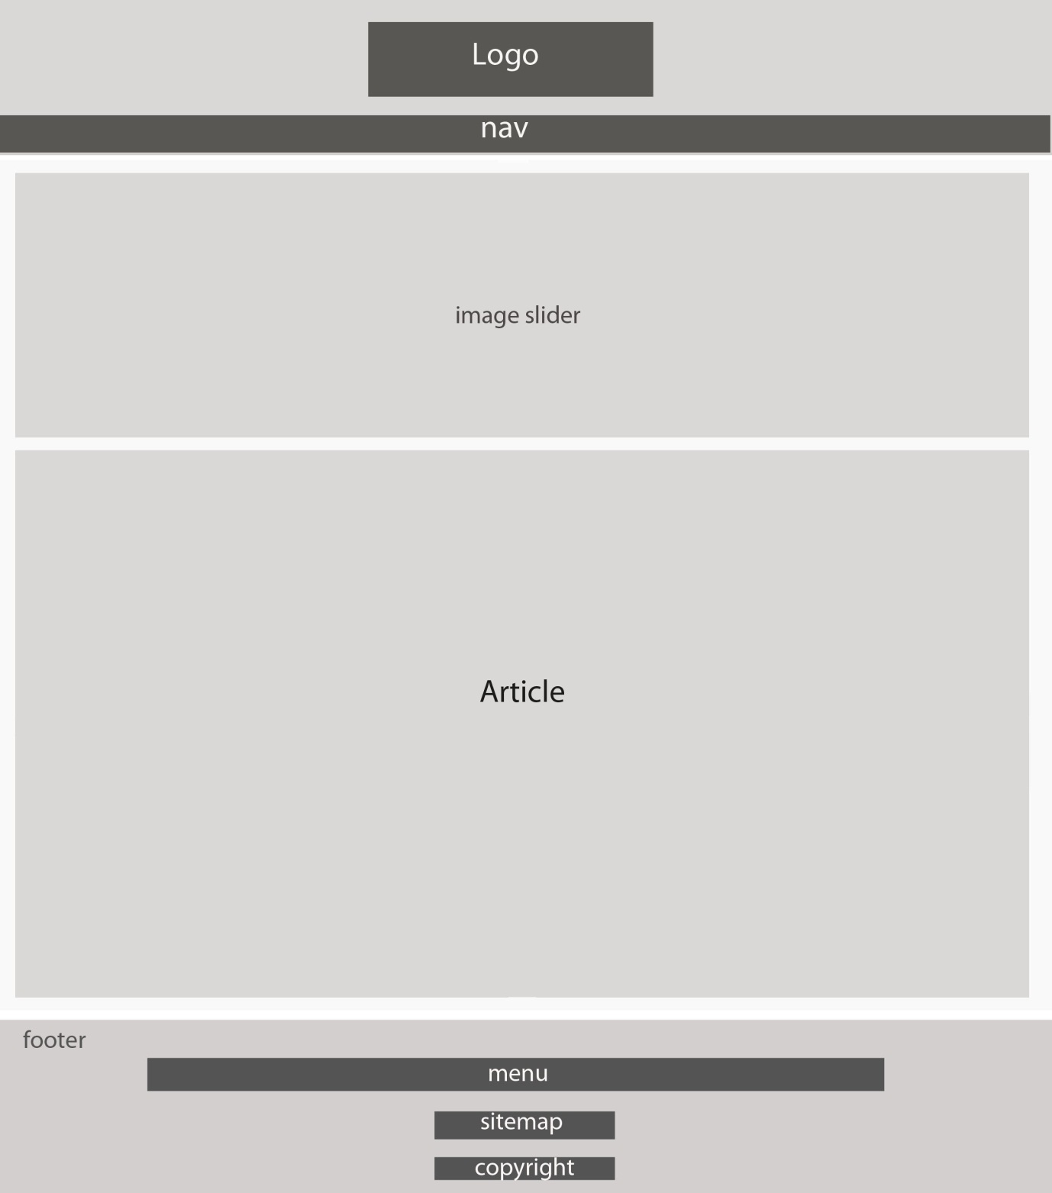

**Storyboards**

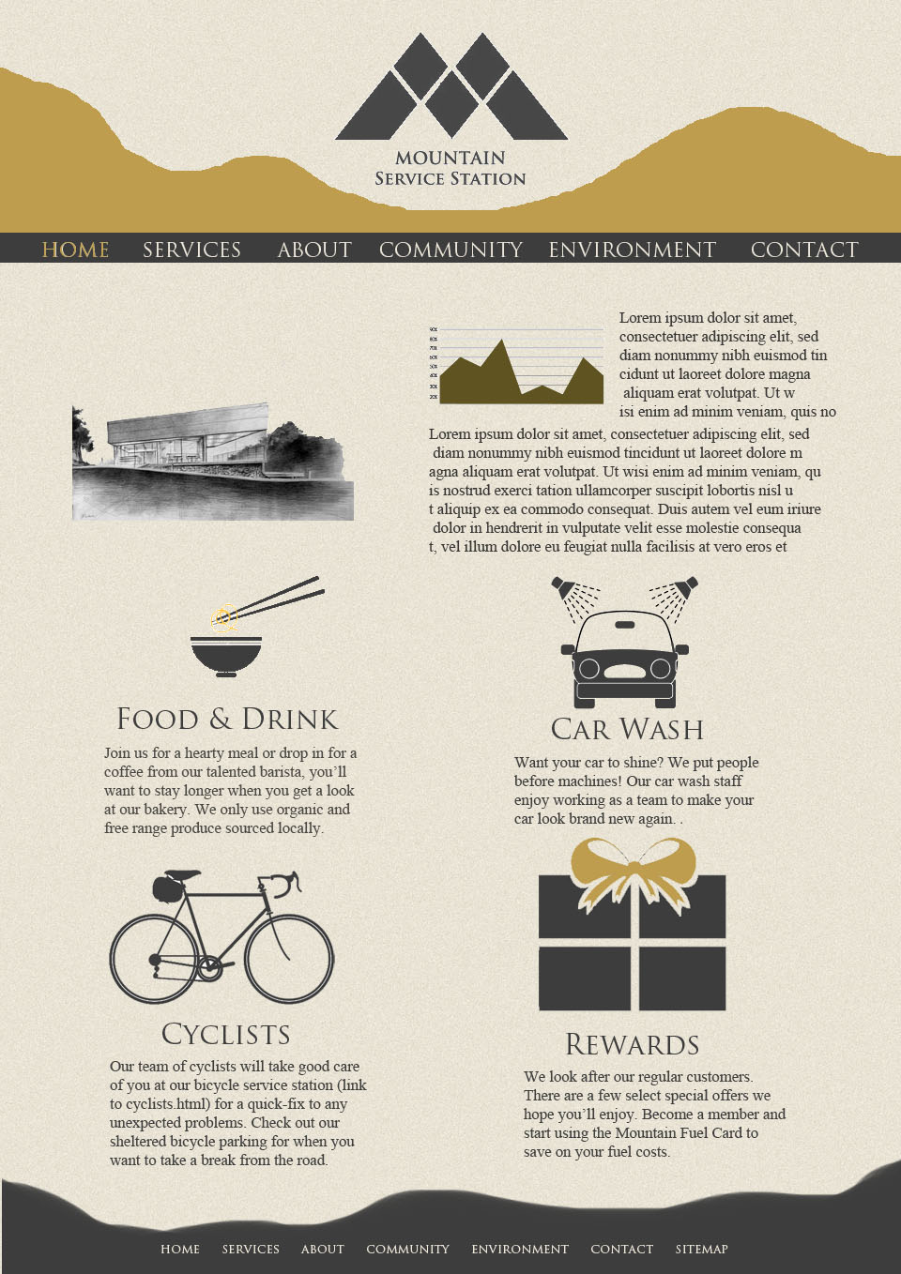

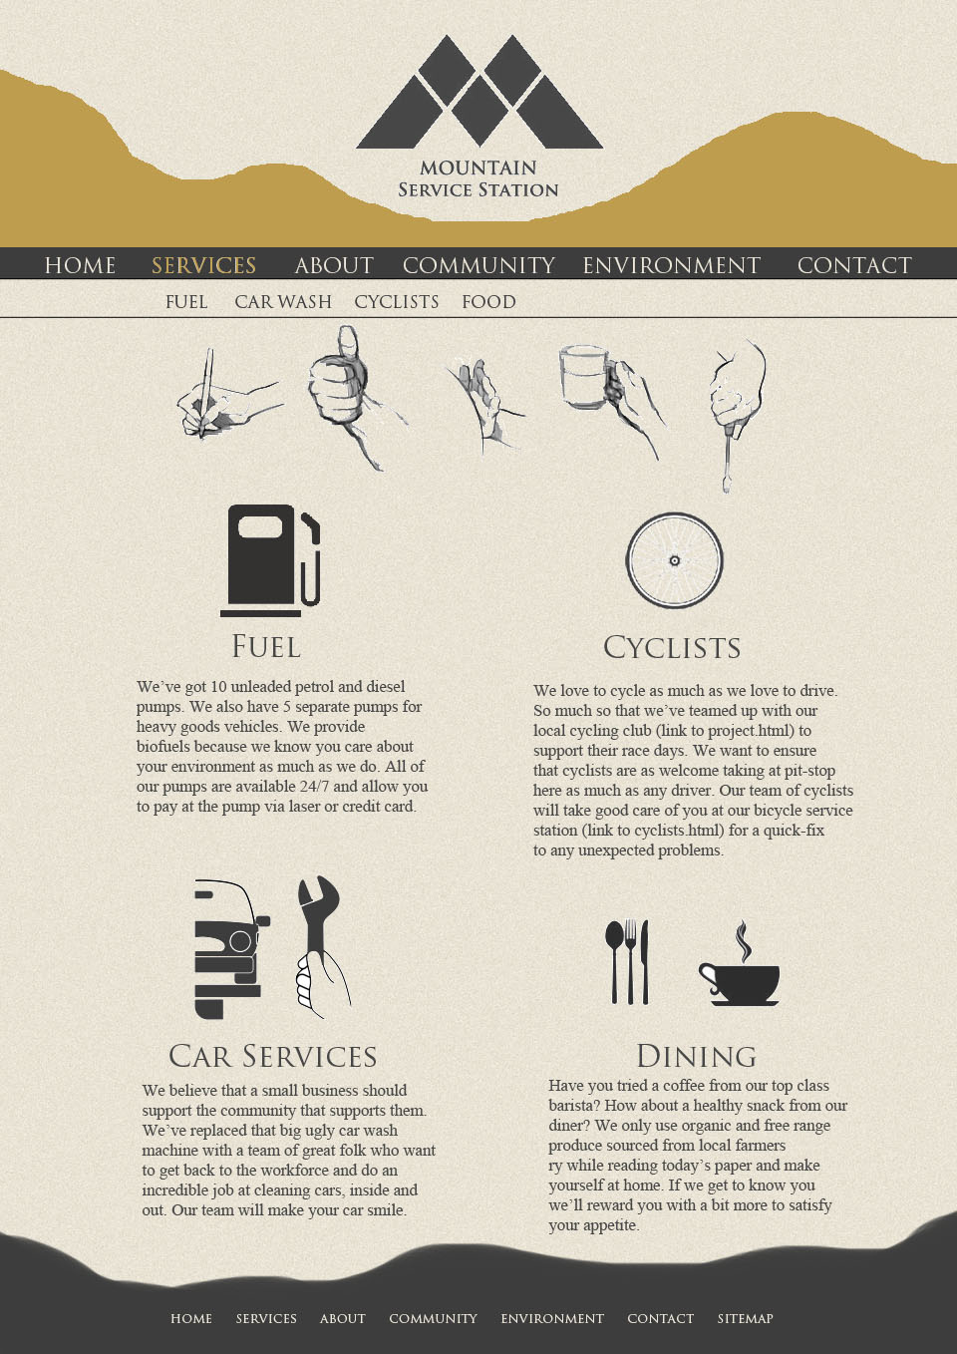

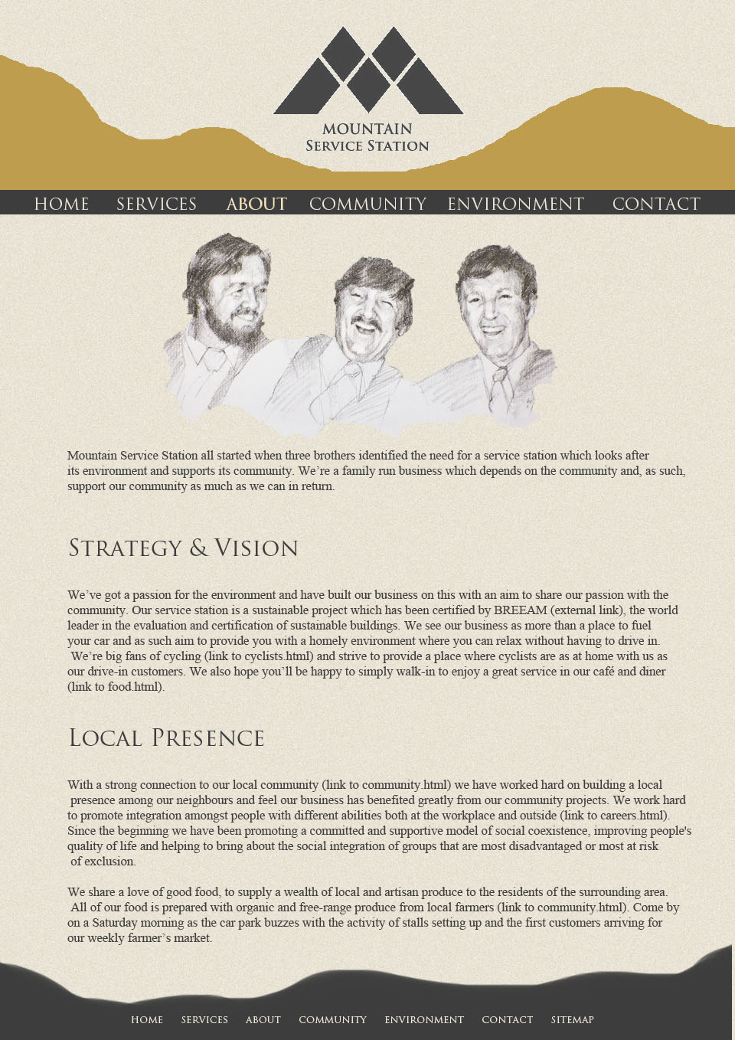

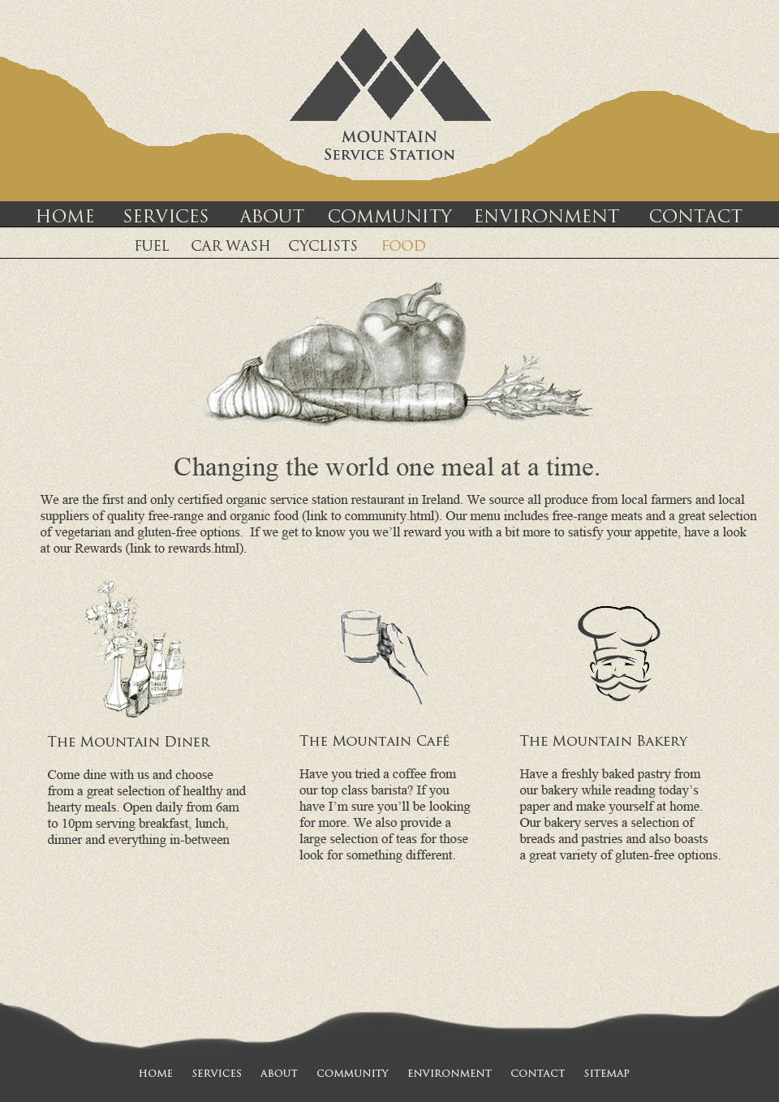

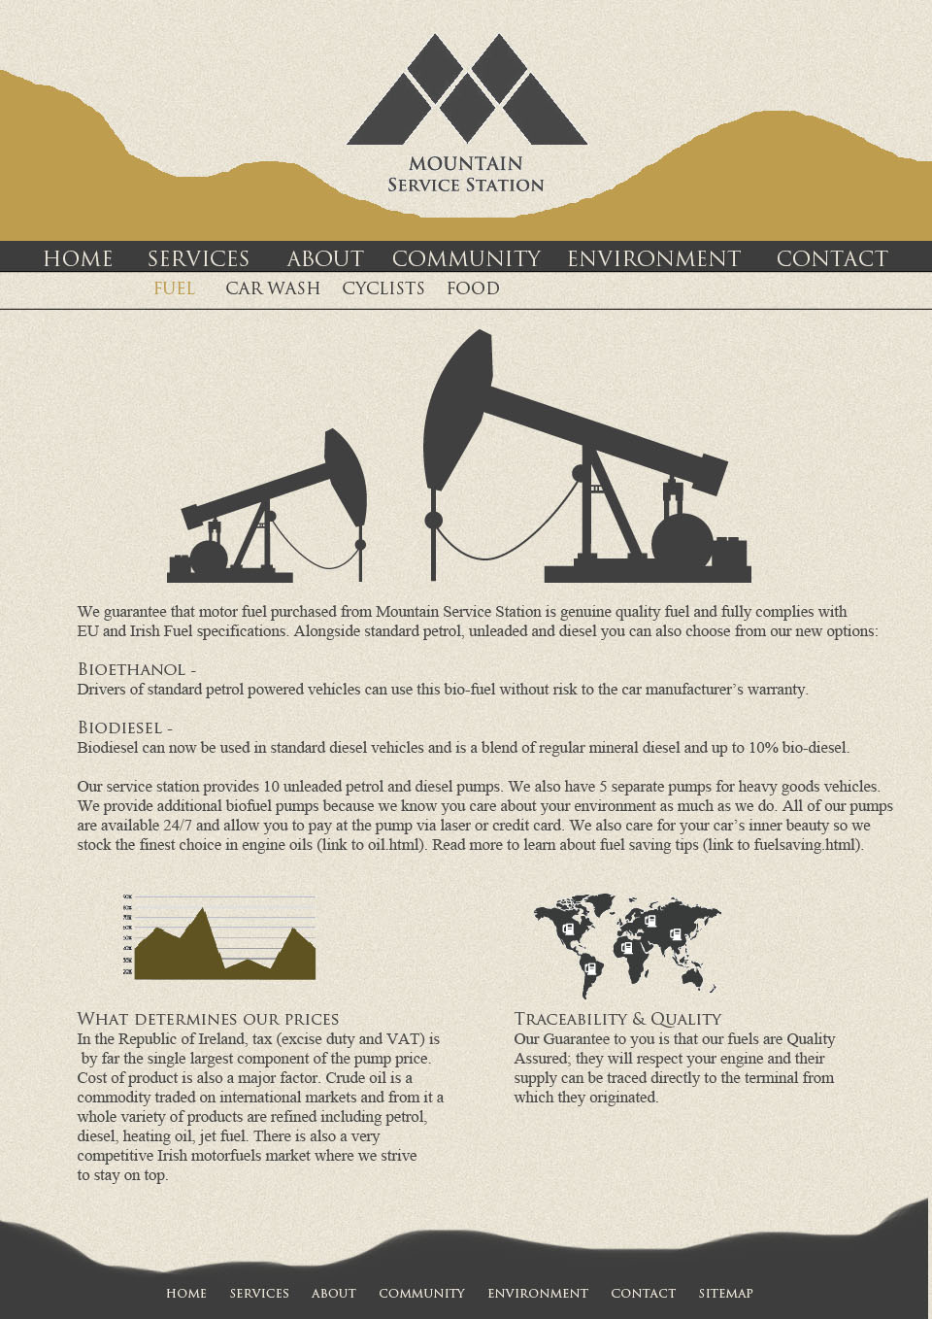

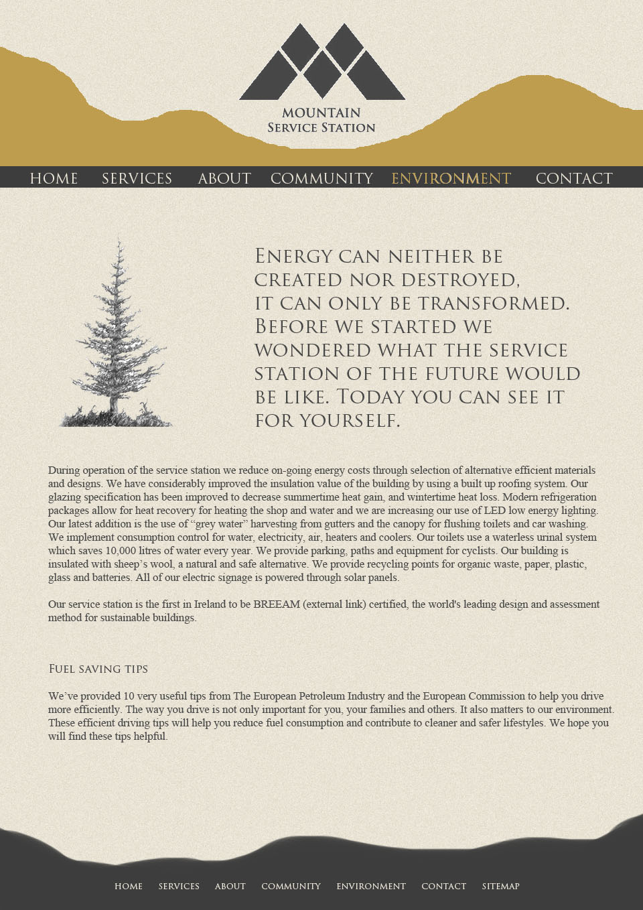

**Stylesheet Guide**

Width: 960px

%-based liquid layout

Font-family: "Trajan Pro", "Times New Roman", serif.

Color: #3d3d3d

Font-size:13px;

Line-height:22px;

h2: font-size:18px;

p: font-family: "Times New Roman", Times, Cambria, serif.

a:link : #be9d4e

a:hover: #3d3d3d ­

**Accessibility**:

All images to include alt-text (note: no audio/visual media included in website).

All pages structured to be read easily if CSS stylesheet is disabled.

Color is not required to display important information.

Content to display clearly if javascript is disabled.

**Usability Questionnaire**

Q: Are the links using meaningful text?

A:

Q: Is the site easily navigable?

A:

Q: Is the site structure & design consistent?

A:

Q: Are meaningful document structures used?

A:

Q: Are colors and fonts used appropriately?

A:

Q: Do pages load quickly?

A:

Name: ____________________

Signature: _________________ Date: _____________